The Needs of Plants

Notes: We start with experiments because we want to understand what the plant needs.

Prerequisite: Parts of the Plant nomenclature cards (download here)

For the sequence of Botany lessons over the course of the elementary years, you’ll require Impressionistic charts.

Botany Impressionistic Charts:
Rhyme & Reason charts (similar to originals but with some updates): purchase here
Hand-drawn option (very close to the originals): purchase here
Realistic photographs (from Montessori for Everyone) : purchase here

Note: the hand-drawn charts are the traditional option, since they inspire children to draw their own. But some families prefer the realistic photographs.

Experiment #1: What a plant needs in order to grow (can start with 5-year-olds)

MATERIALS::
- 4-5 small dishes
- soil
- cotton
- quick-growing seeds (radish and cress are a good option)
  - **Soak 24 hours before**
- slips of paper
- Pen

Note: Plan this experiment for a period of two weeks where the children will be able to attend to the plants daily.

Procedure:
- Sow them with the children in the different elements.
- Explain: We would like to find out what plants need in order to grow in a healthy way. We're going to start with the seeds.
- Four dishes have soil and one has cotton.
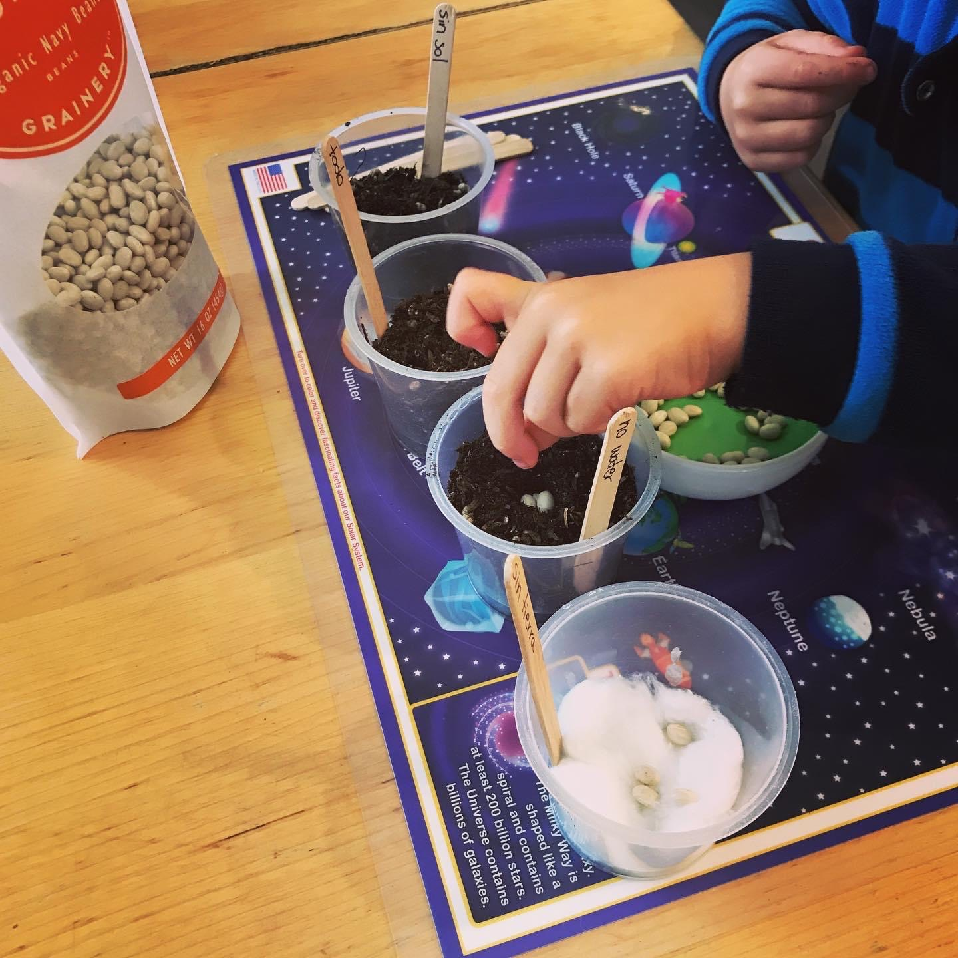
- Scatter approximately the same number of seeds on each dish.
- Ask: What do you think plants need? Children will answer: Water, sunlight, soil. Sun provides light and heat.

Conditions: (make a label for each condition)

dish #1: everything (water, sunlight, soil) (control dish)
dish #2: no light
dish #3: no warmth (optional, put it in the fridge and put a flashlight for light)
dish #4: no water
dish #5: no soil

- It's the children's responsibility to look after the different seeds. Help them make a watering and observation schedule.
- Place the seeds in a room where the children can observe them daily, even on weekends.

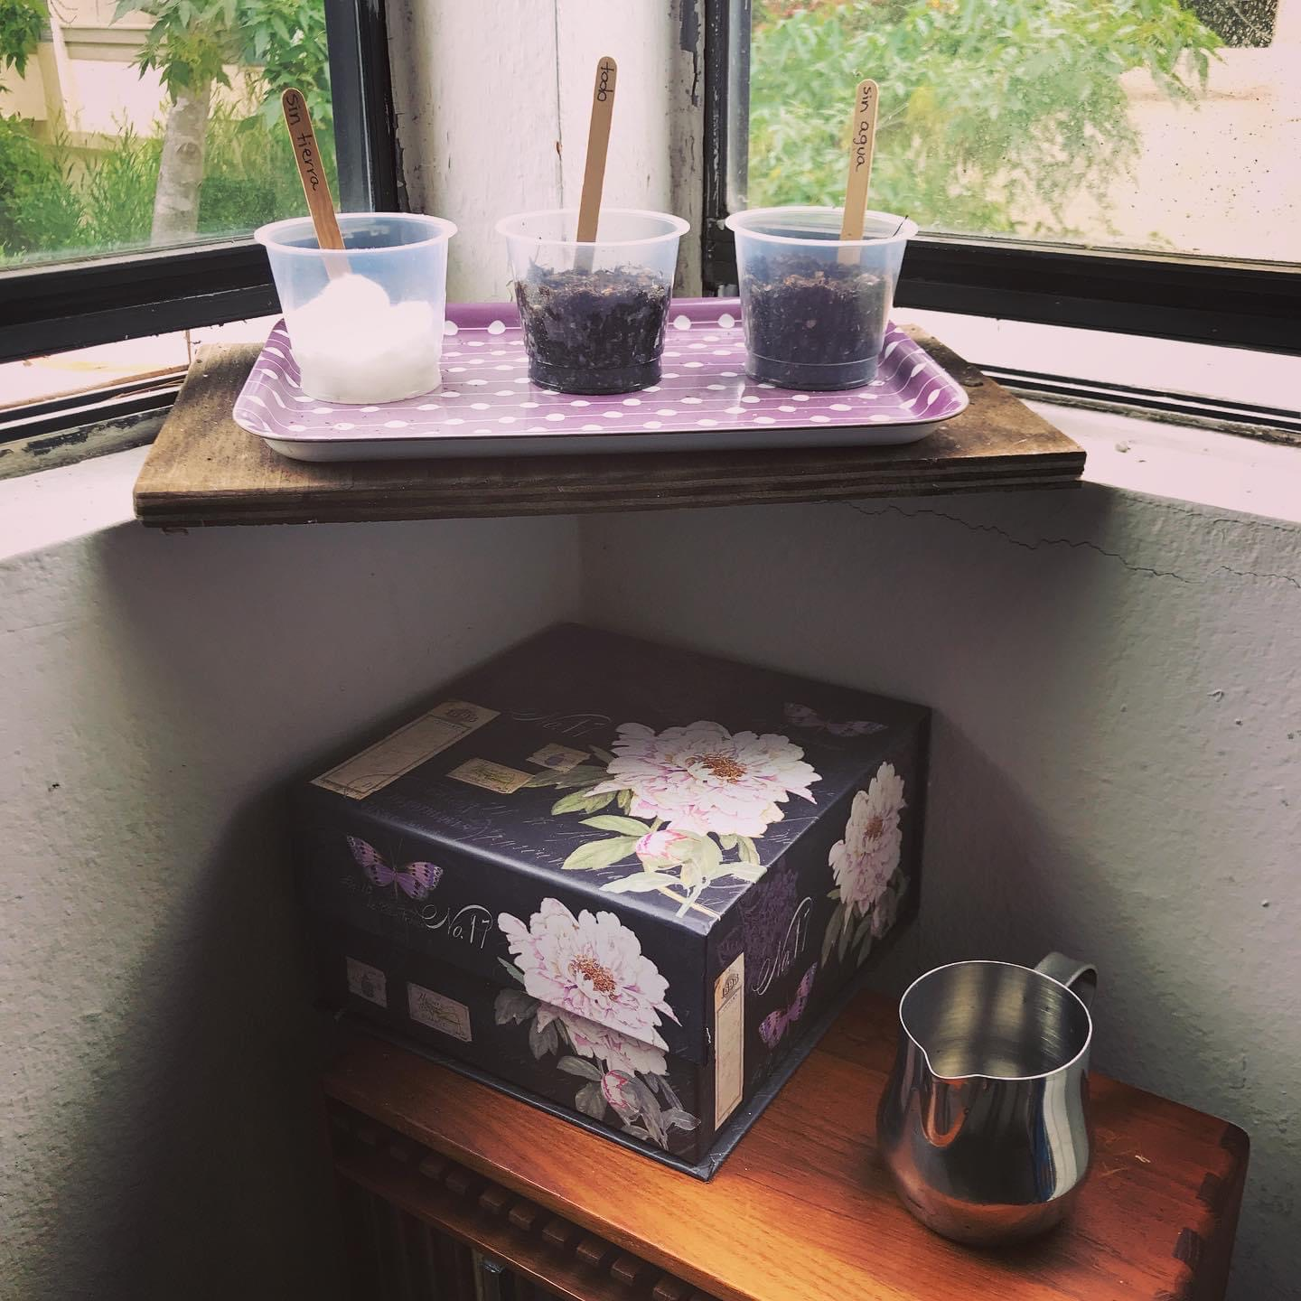
(The seed that gets no light is in the box.)

- When the seeds that have everything are doing well (about 2 weeks), we can compare what happened to all of our seed dishes.
- Invite the children to describe their sprouts.

dish #1: they are green and healthy
dish #2: they are yellow and perhaps long because they were desperate to find light
dish #3 & 4: nothing happened (just seeds)
dish #5: they look green and healthy, but when their store of food runs out they will die.

Conclusion: Plants need warmth, water, light, and soil.

Conversation & chart:
- Show chart #1: Needs of the plant (The chart should re-enforce what we saw in the experiments.)
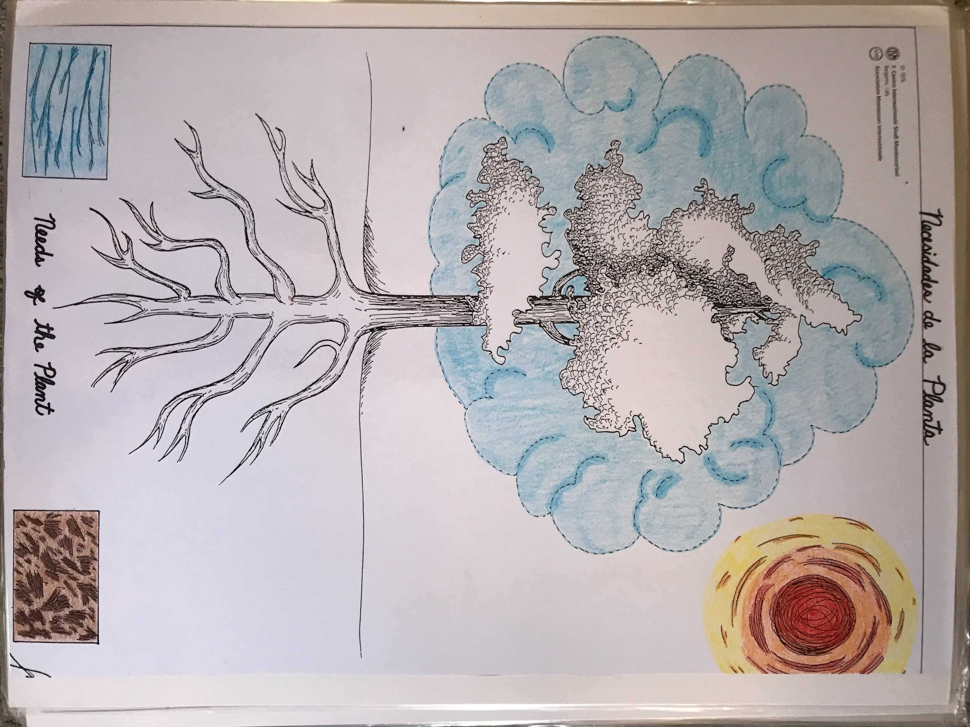
- The plant has the same needs as our seeds. We see the sun colored in. It provides light and warmth. We see the water colored in. We see the soil colored in. There's a sort of cloud around the leaves. It represents the air.
- Let's think about the Story of Life. We heard about a special gas in the air that the plants need. The name of that special gas is carbon dioxide. We have to imagine that the color blue is reminding us of the special gas in the air. It's not just around the leaves, it's everywhere.

Experiment #2: Plants need light

MATERIALS:
- A box that has a lid and two fold-out windows (can be a cardboard shoe box)
- Seeds (pre-soaked)
- a dish
- soil

Procedure:
- Grow them with the windows closed and the lid OFF.
- When they are flourishing, put the lid on the box and open the windows. They will begin to lean against the windows. The longer you leave them, the more they'll poke out.

Conversation:
- We want to keep thinking about the plants needing light.
- They lean out the window, searching for light. They are intelligent, even though they don't have brains like ours. The plants need the light, and so they've leaned towards the nearest source of light.
- They don't move in the sense of going from A to B, but they move in the sense that they lean towards the source of light.

